JClouds API Howto

|  |  |  |  |
| --- | --- | --- | --- |
| **Version** | **Author** | **Date** | **Comments** |
| V1.0 | Autumn Wang | 2/28/2012 |  |
|  |  |  |  |
|  |  |  |  |

1. Abstraction

Jclouds is a common java API for client application communicates with different cloud computers/blobstores. This document will address how to use JClouds in your own java project to communicate with openstack-swift object store.

1. Dependent packages

There are several packaged are needed to run JCloud API in your own project:

* Jcloud blobstore
* Jcloud driver-we will use enterprise driver
* Jcloud swift

The current update to date version is 1.4.0-rc.2. It is wrapped into the jclouds-libs-1.4.0-rc2.tar.gz.

1. Create your own project to use Jclouds API

1). Untar the package jclouds-libs.tar.gz, the new directory structure likes the following:

root@swft001:~/workspace/jcloudswiftclient/target# ls -l lib

total 7284

-rw-r--r-- 1 root root 4467 2012-02-28 15:38 aopalliance-1.0.jar

-rw-r--r-- 1 root root 1876535 2012-02-28 15:38 bcprov-jdk16-1.46.jar

-rw-r--r-- 1 root root 180110 2012-02-28 15:38 gson-2.1.jar

-rw-r--r-- 1 root root 1649781 2012-02-28 15:38 guava-11.0.1.jar

-rw-r--r-- 1 root root 710492 2012-02-28 15:38 guice-3.0.jar

-rw-r--r-- 1 root root 36998 2012-02-28 15:38 guice-assistedinject-3.0.jar

-rw-r--r-- 1 root root 2497 2012-02-28 15:38 javax.inject-1.jar

-rw-r--r-- 1 root root 195389 2012-02-28 15:38 jclouds-blobstore-1.4.0-rc.2.jar

-rw-r--r-- 1 root root 10203 2012-02-28 15:38 jclouds-bouncycastle-1.4.0-rc.2.jar

-rw-r--r-- 1 root root 606602 2012-02-28 15:38 jclouds-core-1.4.0-rc.2.jar

-rw-r--r-- 1 root root 9518 2012-02-28 15:38 jclouds-enterprise-1.4.0-rc.2.jar

-rw-r--r-- 1 root root 10832 2012-02-28 15:38 jclouds-joda-1.4.0-rc.2.jar

-rw-r--r-- 1 root root 11796 2012-02-28 15:38 jclouds-netty-1.4.0-rc.2.jar

-rw-r--r-- 1 root root 461795 2012-02-28 15:38 jersey-core-1.11.jar

-rw-r--r-- 1 root root 543044 2012-02-28 15:38 joda-time-1.6.2.jar

-rw-r--r-- 1 root root 5848 2012-02-28 15:38 jsr250-api-1.0.jar

-rw-r--r-- 1 root root 33015 2012-02-28 15:38 jsr305-1.3.9.jar

-rw-r--r-- 1 root root 790250 2012-02-28 15:38 netty-3.2.4.Final.jar

-rw-r--r-- 1 root root 44209 2012-02-28 15:38 oauth-20100527.jar

-rw-r--r-- 1 root root 106543 2012-02-28 15:38 openstack-common-1.4.0-rc.2.jar

-rw-r--r-- 1 root root 45678 2012-02-28 15:38 rocoto-6.1.jar

-rw-r--r-- 1 root root 76216 2012-02-28 15:38 swift-1.4.0-rc.2.jar

2). Create your own java project in eclipse, add all the jar files into the libraries as the following:

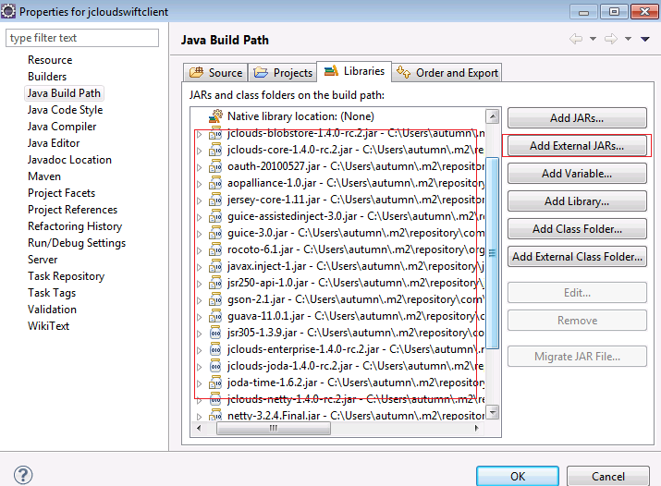

1. Code example

Please refer to the JcloudSwiftClient.java for how to access swift through Jclouds API.